NIHVA TECHNOLOGIES PVT. LTD.
187, G-Block, Thermax chowk, Above Renault Showroom, MIDC
Chinchwad, Pune – 411019.

Contact Person: Mr. Mayur Derle
Mob No.: 7709209333
Web: http://www.nihva.com

AUTOMATION SOLUTION-DIVISION

Ordnance Factory-Pick & Place (Manipulator)

Proposal:
- Pick
- Place
- Rotate

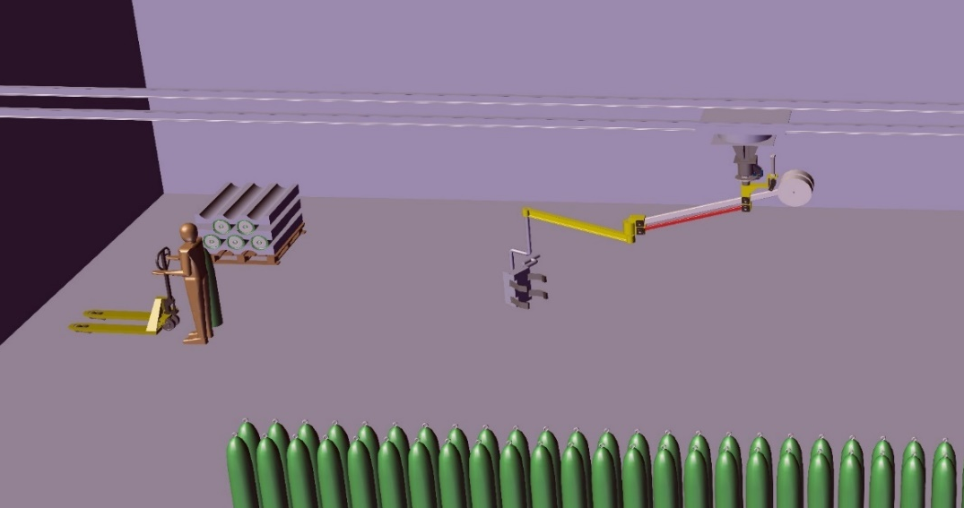

Plant 171

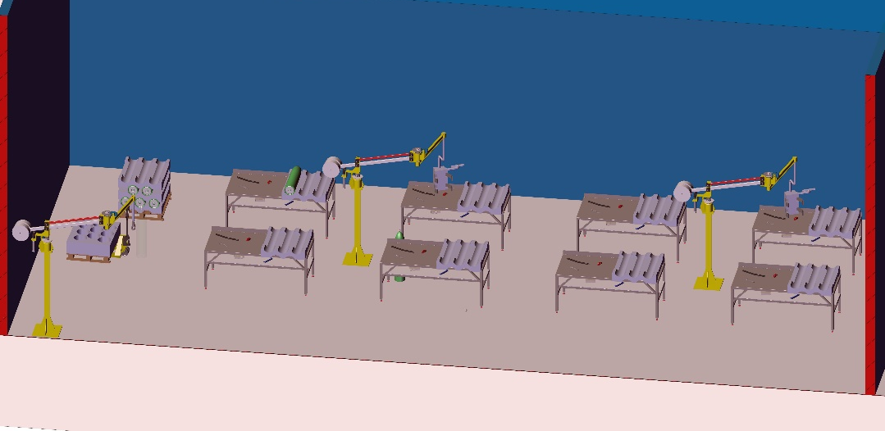
Plant 166

Date: 04.07.2017
To,

Ordnance Factory
Dehuroad, Pune-412101

Kind Attention: Mr. Sanjay Tambole

Dear Sir,

Thank you for giving us an opportunity to participate with our offer on the above project. We enclose here with our proposal includes:

- Requirement
- Scope of Works
- Drawing, Training & warranty
- Details of Application
- Commercial
- Technical Specification
- Terms & conditions

- Requirement
- Energy efficient Design: The Pick & Place system should be energy efficient. The design shall ensure minimum possible power.
- Reduced Manpower: All heavy work will be done by manipulator so this system will require minimum labour work.
- Section ‘A’ will have one manipulator & gripper assembly with railing system along with tilting mechanics of gripper to complete pick & place operation of cylinder.
- Section ‘B’ will have total 3 manipulator or pick & place machines. 1st pick & place require at door place to pick cylinders from BOPT with a hook & to place it on manual stacker. Another two pick & place will require inside in a unit to complete process work. These two manipulators will handle their work without a rail system.

- Scope of work:

The scope of work shall be exclusively on Pick & Place System. This includes picking of
cylinder & placing it to desired location, tilting of cylinders up to 90- 180 degrees.

For the above scope, following set of activities are expected to be performed:

NIHVA Automation Services Scope of supply:

Handling System for Production Process Building no.166 Includes following:

- Design
- Manufacturing
- Successful Trails at our end
- Dispatch at your ends.
- Installation & Commissioning @ ORDNANCE FACTORY DEHURAOD
- Operator & Maintenance Training.
- Warranty of the equipment for 1 year from commissioning date.
- Hard & Soft Copy of Operator & Maintenance Manual -4 sets

- Drawing:

We will issue a full set of shop drawings for approval within 2 weeks of receiving the confirmed
order and finalized design details.

- Training:

After installation of the automation system, we will train the Clients personnel in the operation and basic maintenance, including the understanding of the error codes on the control system (if applicable).

- Warranty:

The warranty period is twelve months from the date of installation and commissioning.

If a defect arises within the warranty period stated, which is attributable to faulty design,
materials or installation workmanship the product will be repaired at our discretion without
charge. This guarantee is subject to proper use of the product and assumes that the product is
regularly serviced and maintained by skilled personnel in accordance with the operation and
maintenance instructions supplied

- Maintenance & Service Agreement:

We would suggest that you take advantage of a maintenance and service agreement on the NIHVA products, which will guarantee trouble free operation and speed of response in an emergency. Customized proposals are available on request

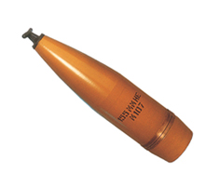
- Details of Application:

- Components Details

- Work piece Description: - Shell (Ammunition)
- Weight: - Max 55 kg approx.
- Diameter: -155 mm
- Model: - C -97 PY-19

Concept Image of Shell

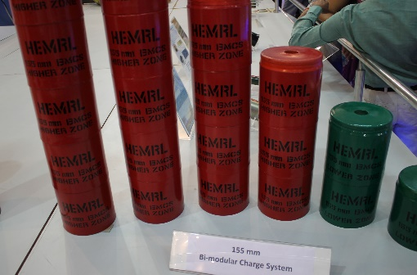
- Components Details

- Work piece Description: - Canister Assembly
- Weight: - Max 10 kg approx.
- Diameter: -120 mm
- Model: - C-97 PY-19

- User requirement details:

- Shift shell from battery truck to hand trolley at Entrance of the Building.
- Lifting and maneuvering the shells to carry out several operations like fixing of canister assembly, pressing of boat tail & fixing of shearing pins.

Sequence of Operation of Assembly Bomb Shell Handling (Ammunition):

Floor Column Mounted Manipulator:
- Pick the Shells from battery truck.
- Place the Shells to hand trolley.
- For Empty Shell C-97 Handling:
- Pick Empty Shell from Pallet (Vertical)
- Place on Shell rotating fixture (Horizontally)

- For Canister Assembly Handling:
- Pick Canister Assembly from Pallet (Vertical)
- Place in Empty Cell C-97 (Vertically)

- For Shell Assembly Handling:
- Pick Loaded Shell with Canister Assembly from Shell Rotating fixture (Horizontally)
- Place in Press Machine vertically for Boot Tail Assembly of Shell C-97 (Vertically)
- For Cell Assembly Handling:
- Pick Shell C-97 from Press Machine after Boot Tail Assembly of cell. (Vertically)
- Place on Drill Machine worktable for drilling (Horizontally)
- For Cell Assembly Handling
- Pick the finalize assembly of C-97 from Drilling station and place on pallet.

- Commercial:

Section 171 – Pick & Place Machine

Sr. No | Description | Qty | Price in  INR/Each | Total Amount  In INR
1. | Manipulator | 1 | 6,84,000.00 | 6,84,000.00
2. | Installation Charges for above manipulator | 1 | 20,000.00 | 20,000.00
3. | Gripper | 1 | 4,75,000.00 | 4,75,000.00
4 | Air Booster & Air Reservoir Tank | 1 | 90,000.00 | 90,000.00
5. | Installation Charges for above Gripper | 1 | 10,000.00 | 10,000.00
6. | Railing System 20 meters | 1 | 7,50,000.00 | 7,50,000.00
6. | Installation Charges for above Railing | 1 | 20,000.00 | 20,000.00
7. | Overhead Structure I Beam | 1 | 4,50,000.00 | 4,50,000.00
A. | Total Amount for Section A-171 |  |  | 24,99,000.00

- Technical Specification:
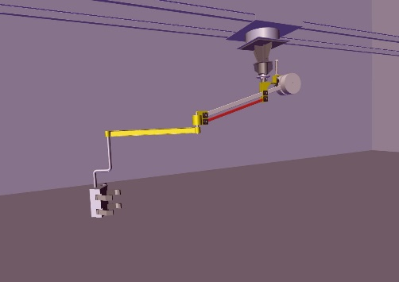
- Manipulator:
- Manipulator: 6 Bar
- Capacity: 150 kg
- Mounting: Rail Mounted
- Reach arm: 3 meters

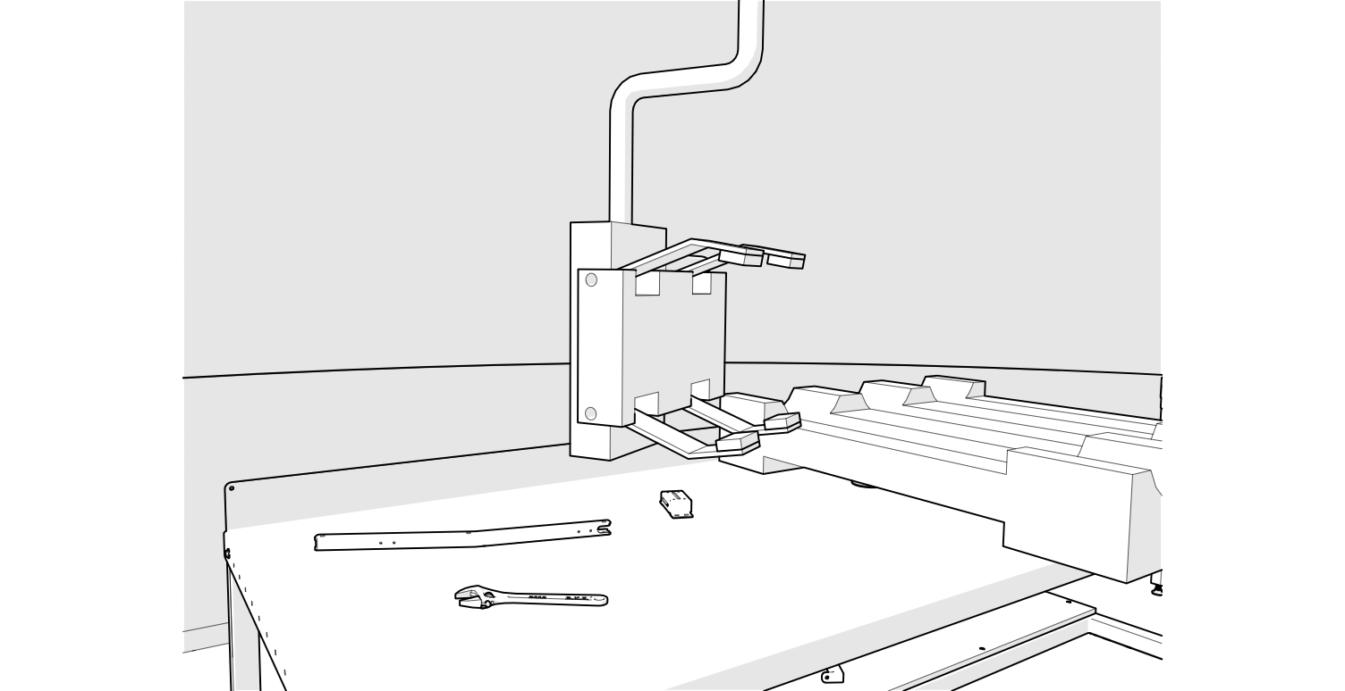
- Gripper
- Clamper Expansion
- Max.: 450mm
- Min.: 100mm
- Min Height: 350mm
- Max. Height: 1650mm
- Rotation: 180 & 90 Degree

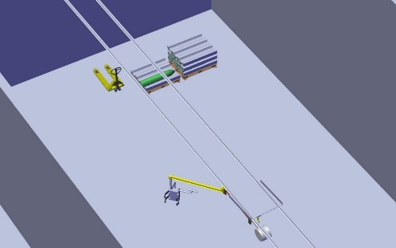
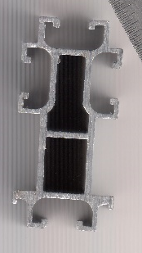
- Rail System
- Length of Rail: 20 meters
Make-CEARS / KONE
Supported by I Beam

- Air Booster & Air reservoir tank:
Booster & reservoir unit is equipped to boost the pressure levels of with aid of low pressure line.
Also, it cleans out moisture from air.
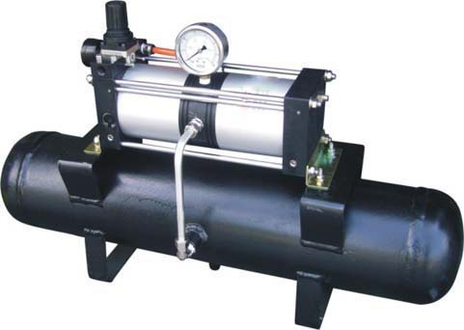

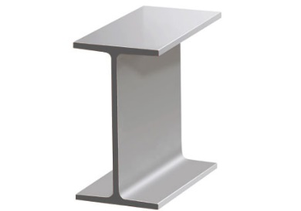
- I Beam: - I beam is used to support rail system.
Size: - ISMB 150x75mm.

Section 166 – Pick & Place Machine

Sr No | Description | Qty | Price in  INR/Each | Total Amount  In INR
1. | Manipulator near Door | 1 | 6,30,000.00 | 6,30,000.00
2. | Installation Charges for above manipulator | 1 | 20,000.00 | 20,000.00
3. | Manipulator | 2 | 6,84,000.00 | 13,68,000.00
4. | Installation Charges for above Manipulator | 2 | 20,000.00 | 40,000.00
5. | Gripper | 2 | 4,75,000.00 | 9,50,000.00
6. | Installation Charges for above Gripper | 2 | 20,000.00 | 40,000.00
7. | Air Booster & Air Reservoir Tank | 2 | 90,000.00 | 1,80,000.00
B | Total Amount for Section B-166 |  |  | 32,28,000.00

Technical Specification

- Manipulator
- Manipulator: 6 Bar
- Capacity: 150 kg
- Mounting: Floor mounted
- Reach arm: 3 meters

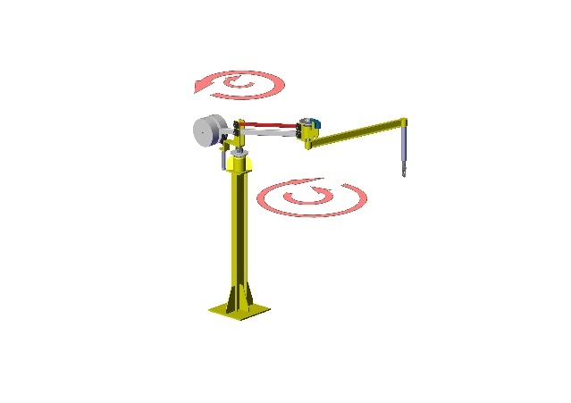
- Manipulator with hook near door
- Manipulator: 6 Bar
- Capacity: 150 kg
- Mounting: Floor mounted
- Reach arm: 3 meters

- Gripper
- Clamper Expansion
- Max.: 450mm
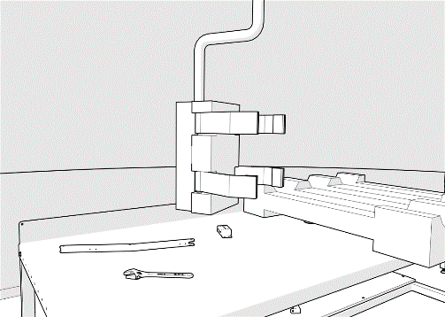
- Min.: 100mm
- Min Height: 350mm
- Max. Height: 1650mm
- Rotation: 180 & 90 Degree

- Air Booster & Air reservoir tank:
Booster & reservoir unit is equipped to boost the pressure levels of with aid of low pressure line.
Also, it cleans out moisture from air.

- Manipulator Technical Illustration:
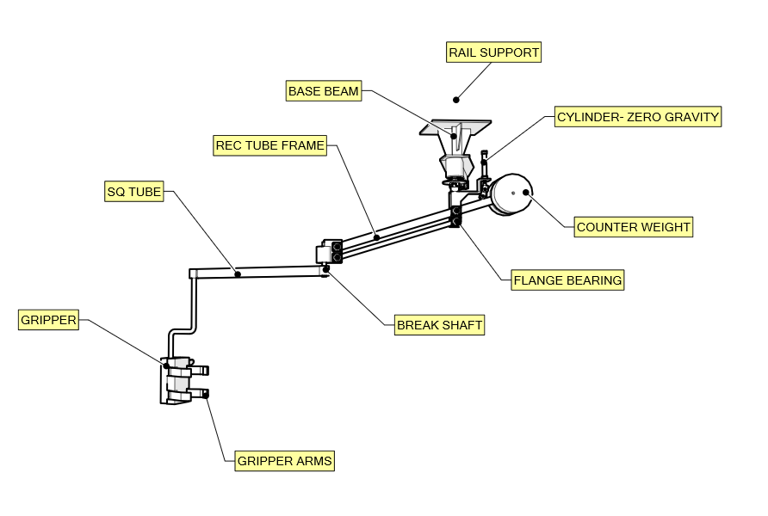

- Safety features

- In case of loss of air, component will not get released. Manual intervention is required after 10-15 min.
- In case of sudden air cut off, manipulator will not come down immediately. It will come down gradually, after take 5 minutes.
- Brakes will have engaged after air cut off. Spring loaded brakes will remain hold manipulator in parking condition when air cut off at night or during holidays.
- Part Presence Sensor on gripper for safe load and no-load balance condition actuation of manipulator.
- FEA will be conducted for critical elements.
- Secondary Safety wire ropes for hangers & trolleys of overhead rails.
- PE Test Certificate (Form 11 by chartered Engineer) will be provided for whole manipulator system.

Ergonomics

  - All Handles, Control switches, Control Box etc. will be mounted at places considering human ergonomics.
  - Human & Manipulator Arm movements will be checked & submitted during DAP

List of Exclusions and Exemptions requested

Exclusions

- Trolley/Fixture for component & its modification.
- Air Drier is not included in this scope. If Air is not Dry & Clean then for smooth & proper functioning of the system, drier is necessary.

E. Terms and Conditions:
- Price: Ex. Works Pune
- P & F Charges: @ 3% of Total supply value.
- Freight Notes: Extra as applicable
- Delivery: within 9-10 weeks from the date of receipt of confirmed purchase order, Advance Payment, Drawing approval.
- Payment :80% Advance along with Confirmed Purchase Order & Balance before dispatch.
- Insurance: Extra as applicable.
- Tax: GST: 28% on total supply value.
- Validity :15 days from the date of quotation.
- Warranty :12 Months from the date of supply.
Please feel free to Contact Mr. Mayur Derle on 7709209333 For any further Clarification in this Concern.

With Best Regards
Pooja Badre
7709586333
For NIHVA Technologies Pvt Ltd

